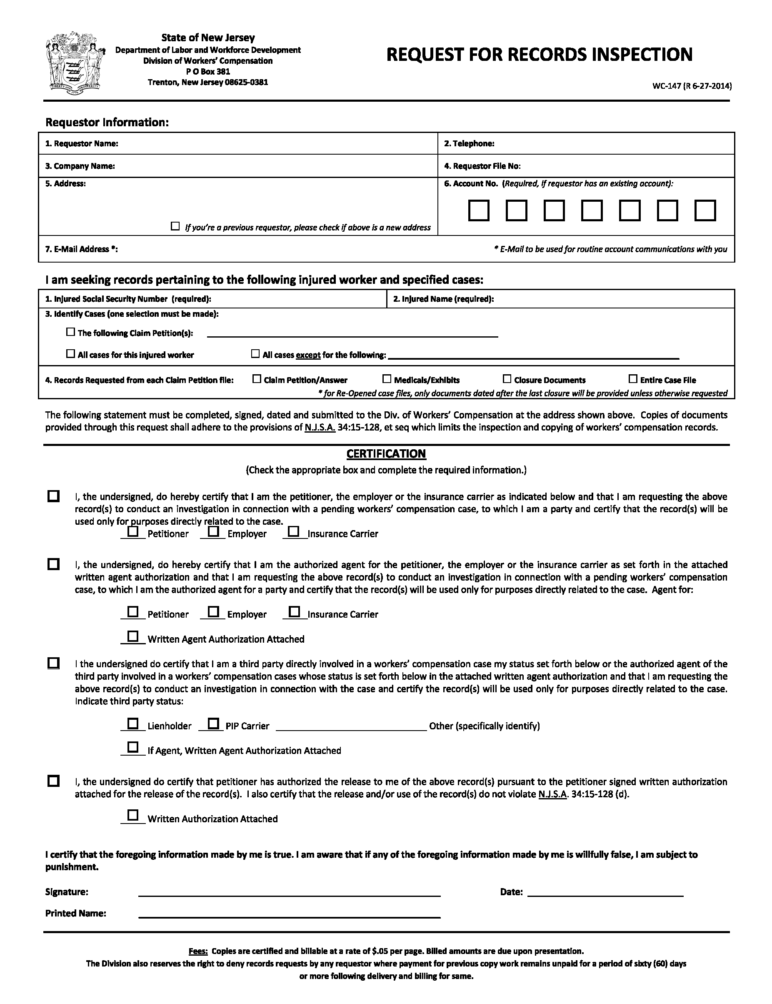

Axiom Requisition Copy Service
2869 Jolly Road
Okemos, MI 48864
(877) 886-5090
01-29018-002
records@axiomcopy.com
xxx-xx-5555
Batman
X
X
X
X

August 16, 2016

